LE EECS 1011 COMPUTATIONAL THINKING THROUGH MECHATRONICS

Kiet Le

LAB C SECTION 10

ID: 218 052 787

September 22, 2020

HAND DRAWN PLOTS

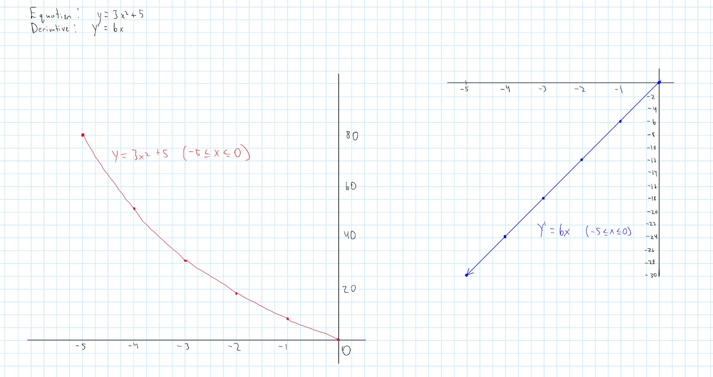

MATLAB PLOTS

